H.T No
Regulations:
A17

Sreenidhi Institute of Science and Technology
(An Autonomous Institution)
Code No: 6K402 Date: 08-Mar-2021(AN)

B.Tech II-Year II- Semester External Examination, March/April - 2021 (Supplementary)
STRUCTURAL ANALYSIS-I (CIVIL)

Time: 3 Hours Max.Marks:75

Note: a) No additional answer sheets will be provided.
b) All sub-parts of a question must be answered at one place only, otherwise it will not be valued.
c) Missing data can be assumed suitably.

ANSWER ANY 5 OUT OF 8 QUESTIONS. EACH QUESTION CARRIES 15 MARKS.

Bloom's Cognitive Levels of Learning (BCLL)

Remember | L1 | Apply | L3 | Evaluate | L5
Understand | L2 | Analyze | L4 | Create | L6

 |  |  | BCLL | CO(s) | Marks
1. | a) | A plane frame ABCDEFGH shown in figure below has clamp supports at A and axial force release (horizontal sleeve) at ‘C’ and moment release (hinge) at E. The static indeterminacy of the frame is. The static (d_{s}) and kinetic (d_{k}) indeterminacies respectively are  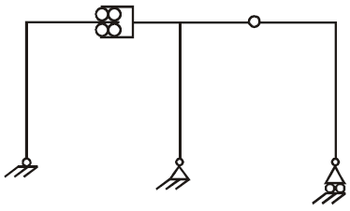 | L3 | CO1 | [8M]
 | b) | Write the difference between statically determinate and indeterminate structures and give the examples of each. | L2 | CO1 | [7M]
2. | a) | Using method of joints, determine the forces in the members of the truss shown below.  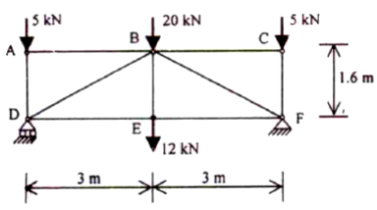 | L3 | CO2 | [8M]
 | b) | The force in the member ‘CD’ of the truss in Figure is  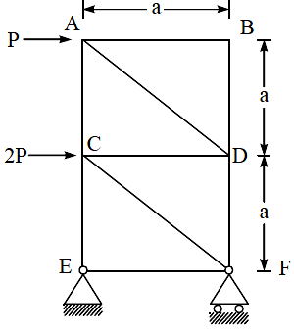 | L3 | CO2 | [7M]
3. | a) | Analyse the beam as shown in Figure below and draw BMD. Use Slope Deflection Method.  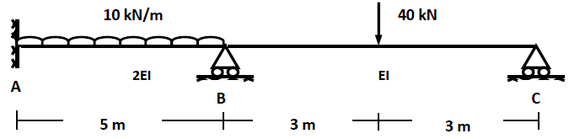 | L4 | CO3 | [8M]
 | b) | Explain about an effect of sinking of support or settlement of support in slope deflection method. | L2 | CO3 | [7M]
4. | a) | Analyse the beam as shown in Figure below and draw BMD. Use Moment Distribution Method.  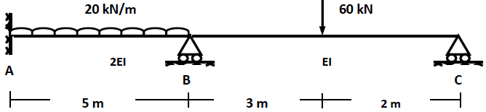 | L4 | CO4 | [8M]
 | b) | Explain about the lateral stiffness and modified lateral stiffness factors. | L2 | CO4 | [7M]
5. | a) | Analyse the structure shown in figure using Kani’s method and draw BMD.  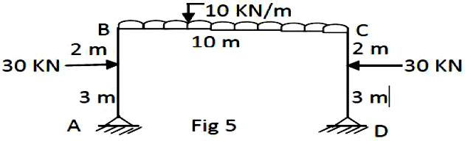 | L5 | CO5 | [8M]
 | b) | Define stiffness of joint in Kani’s method. | L1 | CO5 | [7M]
6. | a) | Draw shear force and bending moment diagrams for the fixed beam shown Figure below. Take w = 30 kN/m and L = 12 m.  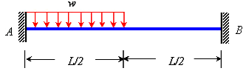 | L4 | CO6 | [8M]
 | b) | Write the advantages and disadvantages of fixed beams compared to simply supported beams | L4 | CO6 | [7M]
7. | a) | The degree of static indeterminacy of the pin-jointed plane frame as shown in figure as shown in Figure is  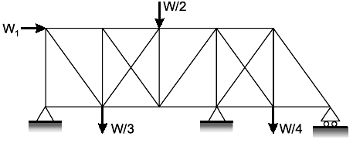 | L4 | CO1 | [5M]
 | b) | Determine the forces in the members in the following truss.  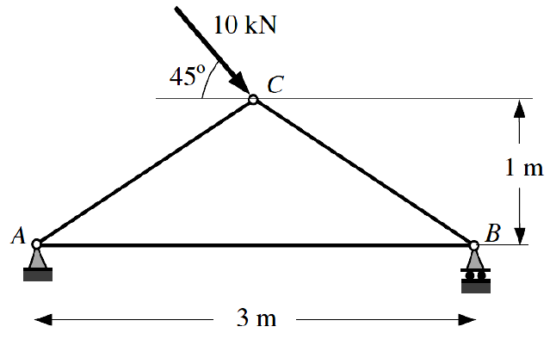 | L3 | CO2 | [5M]
 | c) | Explain about the lateral displacement factor in slope deflection method. | L2 | CO3 | [5M]
8. | a) | Explain about the distribution factors in Moment Distribution Method. | L2 | CO4 | [5M]
 | b) | Explain about the sway correction in Kani’s Method. | L2 | CO5 | [5M]
 | c) | Draw the bending moment diagram for propped cantilever having Uniformly Distributed Load (UDL) on entire span with magnitude of w = 30 kN/m as shown in Figure. Take L = 15 m.  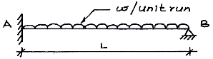 | L3 | CO6 | [5M]

-- 00 -- 00 –

